# DAD 220 Module Five Major Activity Template

## Overview

Review the scenario for this activity in the guidelines and rubric. Then complete the steps below as you work through the directions for this activity. Replace the bracketed text with your screenshots and responses to the prompts. Size each screenshot and its explanation to fit approximately one-quarter of the page with the description written below the screenshot. Review the Template Screenshot Example linked in the guidelines and rubric for this assignment to see an example of how screenshots for your assignment should look.

## Create a Database

1. **Write SQL commands** that capture specific, usable data that can be used in your analysis.
2. **Analyze the results of queries** to identify specific information that can be presented in your summary.
   1. Sales by region:
      1. Analyze sales data by state to determine where the company has the largest customer base.

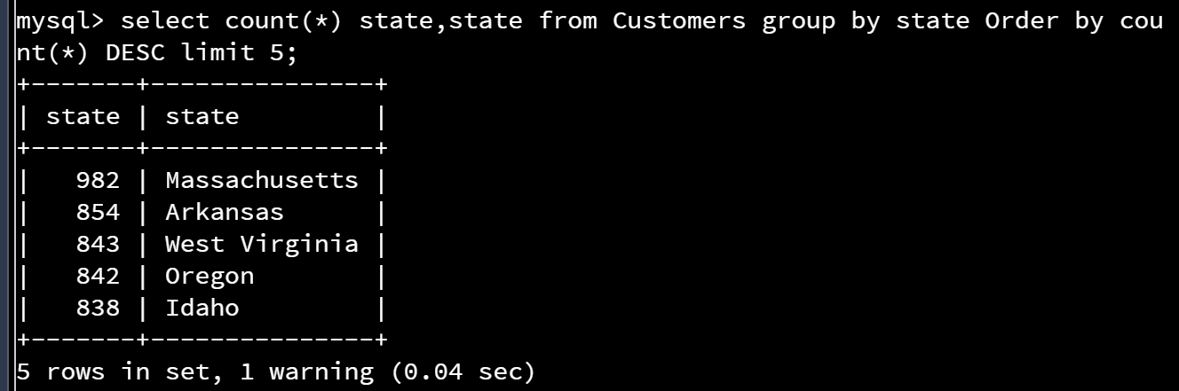

The largest market i ins Massachusetts with customer base of 982 customers with multiple states around 820-850 customers.

* + 1. Analyze the data to determine the top three products sold in the United States.

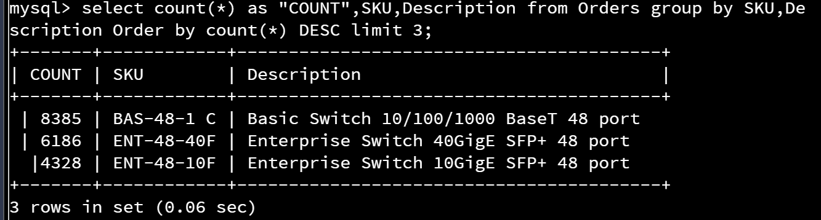

The top 3 sku are shown above with relative quantities. The search routine did not need to include the country as the customer data field does not include foreign country customer data.

* + 1. Analyze the data to determine the top three products sold in the southeastern region of the United States.
* Southeastern states to include in your analysis: Virginia, North Carolina, South Carolina, and Georgia

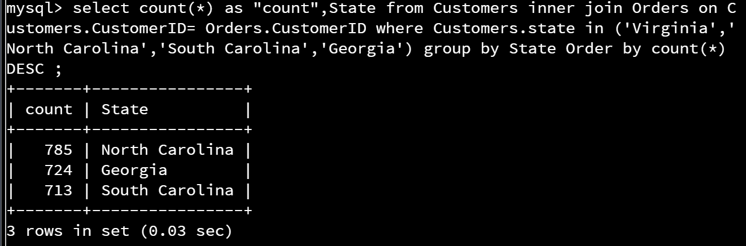

There are no current orders from Virgina. Total orders across other 3 states are shown above. Selecting top product SKU from this region, yields the following SKUs

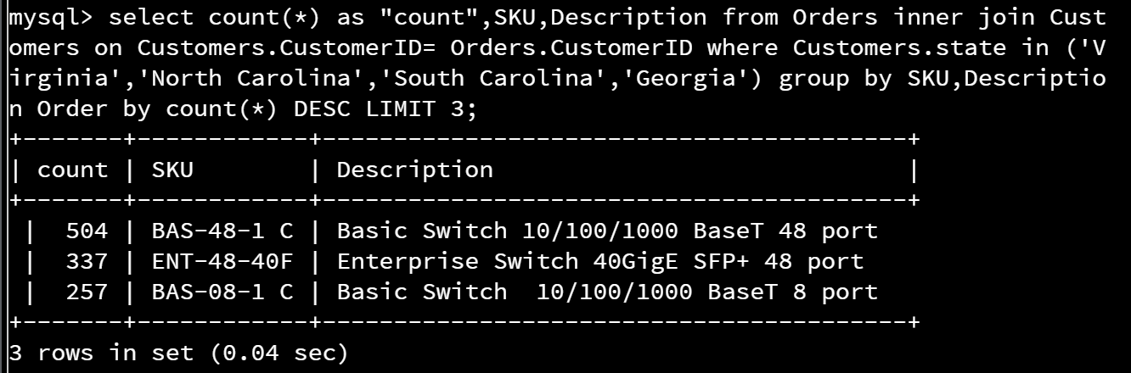

* 1. Returns by region:
     1. Analyze the data to determine the top three products returned in the United States.

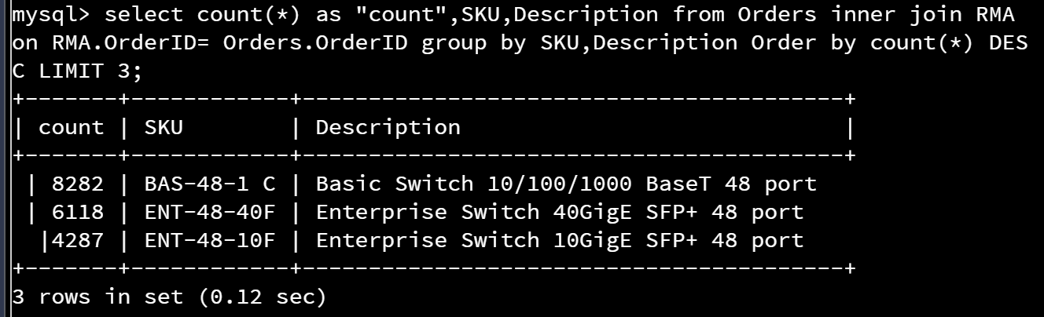

* + 1. Analyze the data to determine the top three products returned in the northwestern region of the United States.
* Northwestern states to include in your analysis: Washington, Oregon, Idaho, and Montana

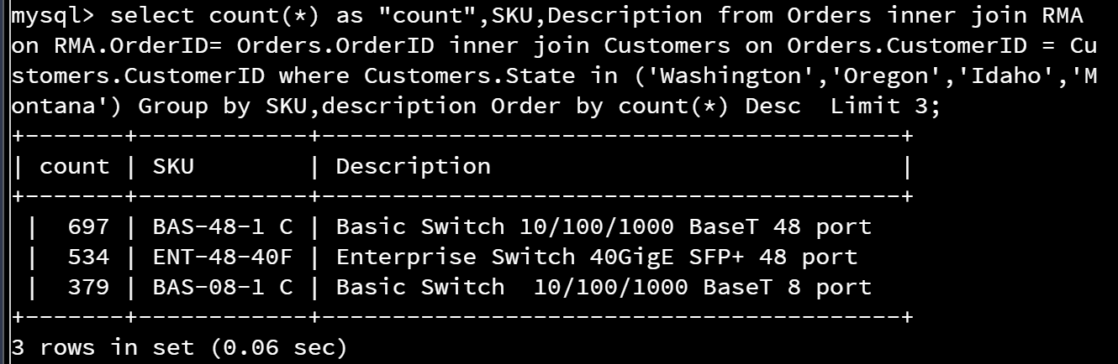

Data on top 3 RMA SKU by Northwest region States is shown above.

1. **Write a report** to the Quantigration product manager that explains your findings in a way nontechnical stakeholders can understand and use.
   1. Provide an effective summary of your findings from the analysis of the sales and returns data you captured. Write at least one paragraph for each of your responses to the prompts below.
      1. Sales data by region: Provide a well-written summary of findings from your analysis in Step Two, Part A.

When considering the sales base in the United States, the largest market is in Massachusetts with state customer base of 982 customers with multiple states around 820-850 customers. Depending on the business objectives, these would be preffered areas for a targeted sales marketing campaign or if the intent is to increase market, these would be regions to consider reduce spending to allow for more emphasis in the smaller markets. The SouthEast region generally speaking has low product adoption and might be an area of emphasis.

The top selling products in all regions are the following SKUs BAS-48-1 C (8385 units), ENT48-40F (6186 units), and ENT-48-10F (4328 units). From this data, it can be summarized that customers appear to interested primarily in the 48 port connectivity solutions over other smaller count connectivity solutions. For designing next generation products, this needs to be a consideration of primary importance based on market adoption.

* + 1. Returns data by region: Provide a well-written summary of findings from your analysis in Step Two, Part B.

When reviewing the customer RMA data, the data shows an alarming trend. Specifically across the united states, the RMA data indicates that a very high complaint percentage exists. SKU BAS-48-1 C (install base 8385 units), suffered from 8282 RMA events (98.7% complaint rate), ENT-48-40F (install base of 6186 units), suffered from 6118 RMA events (98.9% complaint rate) and ENT-48-10F (4328 install base), suffered from 4287 RMA events (99.1% complaint rate.

The NorthWest region overall has highest return rates on the BAS-48-1C and ENT-48-40F SKUs which align with the national trends, but a local increased return on the BAS-08-1 C SKU, but overall unit counts for this region account for less than 10% of the national complaints.